Introduction to Software Engineering

Contents
1. System Vision Document 2
2. Stakeholder Identification 2
3. Functional Requirements 2
4. Requirements Elicitation Techniques 3
5. Interview Agendas 4
A. Internal Operational Stakeholder – Receptionist 4
B. Internal Executive Stakeholder – Hospital Administrator 4
6. Questionnaire for Operational Users 4
7. Workflow Documentation (to be modeled in StarUML) 5
Activity Diagram 1: Patient Appointment Booking Process 5
Activity Diagram 2: Billing and Discharge Process 6
Jira Project Management dashboard 7
Assumptions 10

1. System Vision Document
Vision Statement:
The Hospital Management System (HMS) aims to streamline and automate hospital operations through a centralized, digital platform that integrates patient management, doctor scheduling, billing, and recordkeeping. By reducing manual paperwork and minimizing errors, HMS enhances efficiency and accuracy in healthcare administration. The system provides quick, secure access to critical data for authorized users, supporting improved decision-making, operational transparency, and better patient experiences. HMS targets hospitals seeking to modernize their processes while ensuring scalability and reliability for daily operations.

2. Stakeholder Identification
Category | Stakeholders | Interests / Concerns
Operational Stakeholders | Doctors, Nurses, Receptionists, Pharmacists | Efficient patient data access, appointment scheduling, reduced paperwork, accurate billing, and quick updates on records.
Executive Stakeholders | Hospital Administrator, IT Manager, Finance Manager | System performance, cost efficiency, data accuracy, compliance, and reporting capabilities.
External Stakeholders | Patients, Vendors (equipment/pharmacy suppliers) | Secure access to personal medical data, accurate billing, appointment booking, and reliable service.
Technical Stakeholders | Software Developers, System Administrators, Database Engineers | Reliable performance, maintainability, scalability, and data integrity of the HMS.

3. Functional Requirements
- Patient Management – Register, edit, and delete patient records; view medical history.
- Doctor & Staff Management – Maintain staff profiles, manage schedules, and assign duties.
- Appointment Scheduling – Create, update, and cancel appointments; view doctor availability.
- Billing Module – Generate, track, and print invoices for patient services.
- Report Generation – Create summary reports on patients, doctors, and billing activities.
- Authentication and Authorization – Role-based login for admins, doctors, and receptionists.
- Database Management – Centralized storage of all hospital data with backup functionality.
- Pharmacy Management (Optional) – Track prescribed medications and manage inventory levels.

4. Requirements Elicitation Techniques
Technique | Purpose | Justification
Interviews | Gather detailed, context-specific insights from hospital staff (doctors, receptionists, administrators). | Provides qualitative understanding of operational needs and pain points.
Questionnaires | Collect structured data from a large group of users (nurses, clerical staff, etc.). | Efficiently captures common requirements and usability expectations.
Observation | Observe daily workflows and bottlenecks in patient registration and appointment handling. | Ensures accurate understanding of current processes.
Document Analysis | Review existing paper forms and reports used in the hospital. | Helps design digital equivalents and ensures all required data fields are captured.

5. Interview Agendas

A. Internal Operational Stakeholder – Receptionist
Topics & Questions:
- Describe your daily workflow for patient registration and appointment scheduling.
- What challenges do you face with the current manual system?
- How do you manage cancellations or rescheduling?
- What features would make your work faster or more accurate?
- How often do you interact with doctors or billing staff when handling patient data?
- Do you face data duplication or loss?
- How do you prefer the interface to be designed for ease of use?

B. Internal Executive Stakeholder – Hospital Administrator
Topics & Questions:
- What are your primary goals for implementing an HMS?
- What key metrics or reports are most important for decision-making?
- How do you currently track staff performance and patient throughput?
- What concerns do you have regarding data security and system maintenance?
- What level of control do you need over system configurations and user permissions?
- How would you measure the system’s success after deployment?
- Are there any compliance or audit requirements the system must satisfy?

6. Questionnaire for Operational Users
Please rate each statement on a scale of 1 (Strongly Disagree) to 5 (Strongly Agree).
Question | Rating (1–5)
The current hospital management process is time-consuming.
I frequently face issues retrieving patient information.
I need a system that simplifies appointment scheduling.
It’s difficult to generate patient or billing reports manually.
I would like automated alerts or reminders for appointments.
The system should allow easy access to patient history.
I prefer a user-friendly interface with minimal training required.
Data security and privacy are my top concerns.
The system should reduce paperwork and manual entries.
I would recommend adopting a digital HMS in our hospital.

7. Workflow Documentation (to be modeled in StarUML)

Activity Diagram 1: Patient Appointment Booking Process
- Steps:
  - Patient requests appointment →
  - Receptionist checks doctor’s schedule →
  - Appointment availability confirmed →
  - Appointment recorded in HMS →
  - Confirmation sent to patient.
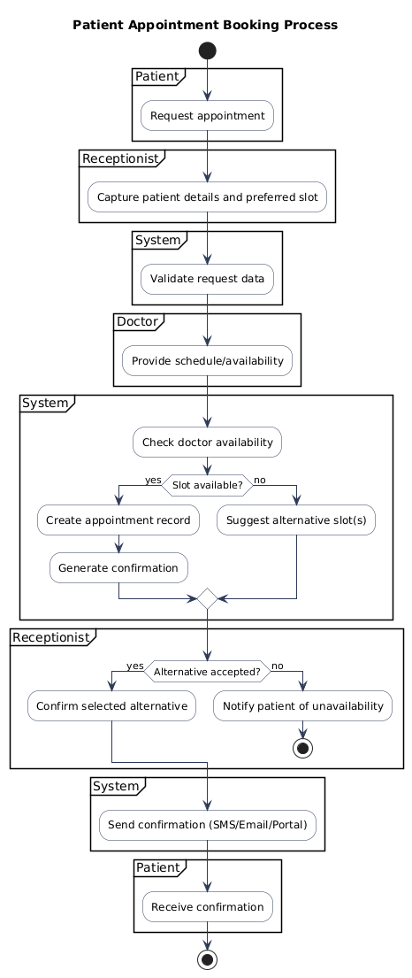

Activity Diagram 2: Billing and Discharge Process
- Steps:
  - Doctor finalizes treatment →
  - Billing staff generates invoice →
  - Patient reviews and pays bill →
  - System updates billing records →
  - Patient discharged and record archived.
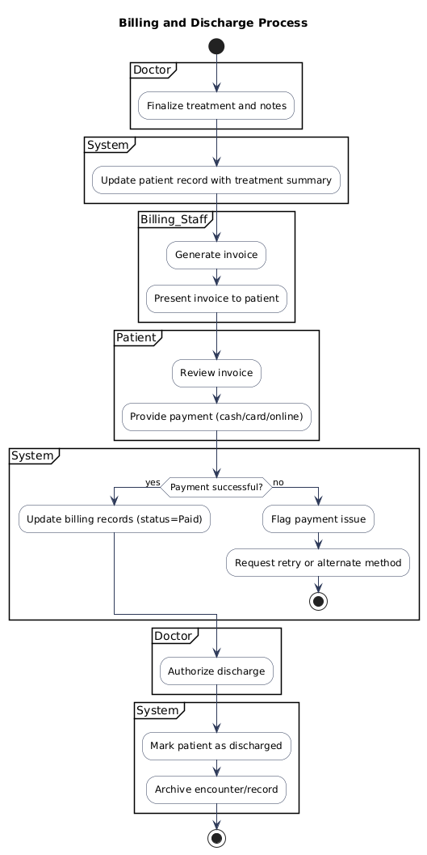

Jira Project Management dashboard

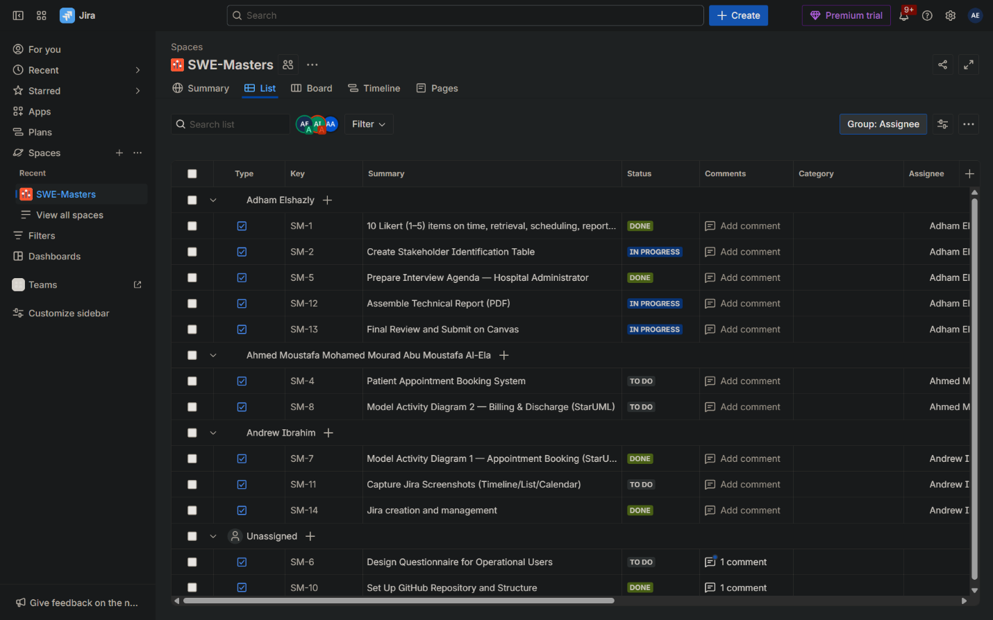
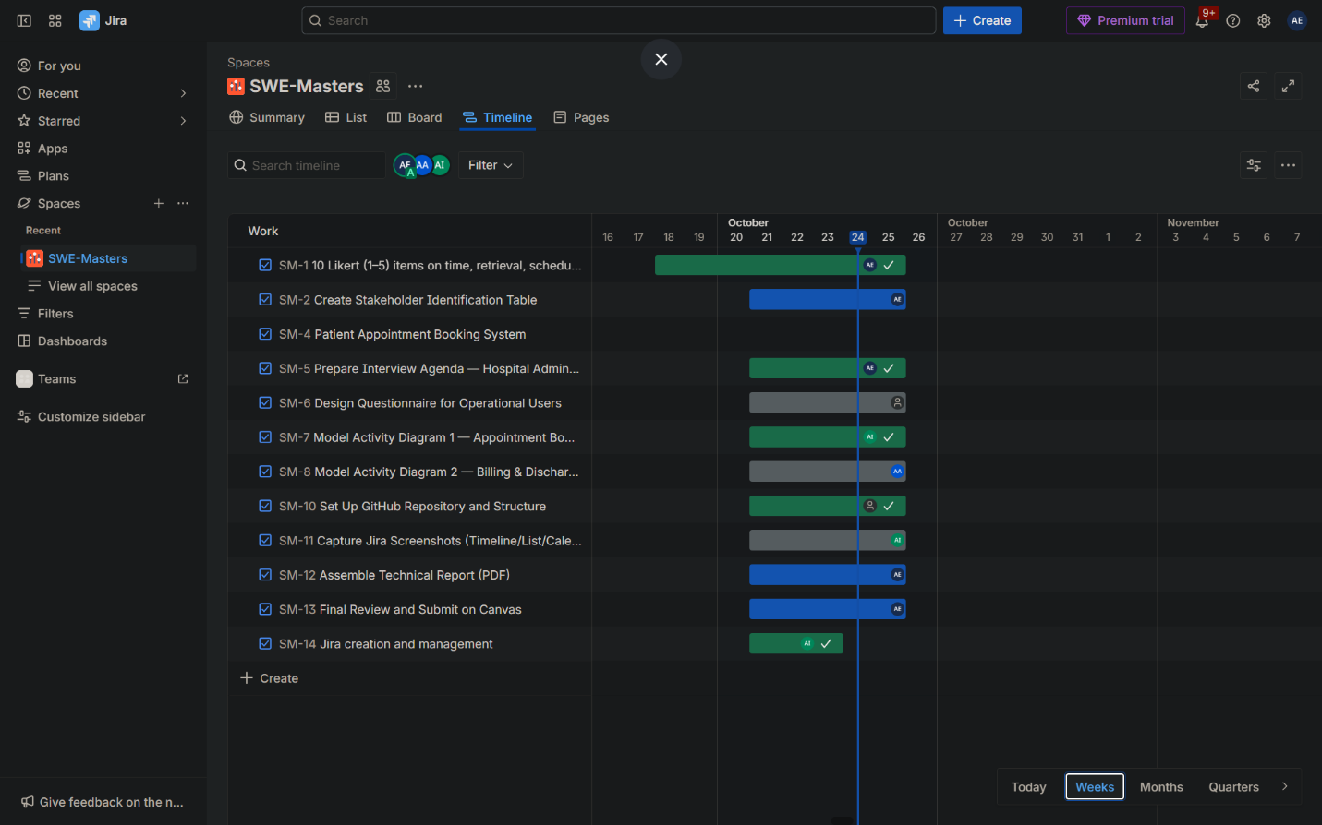
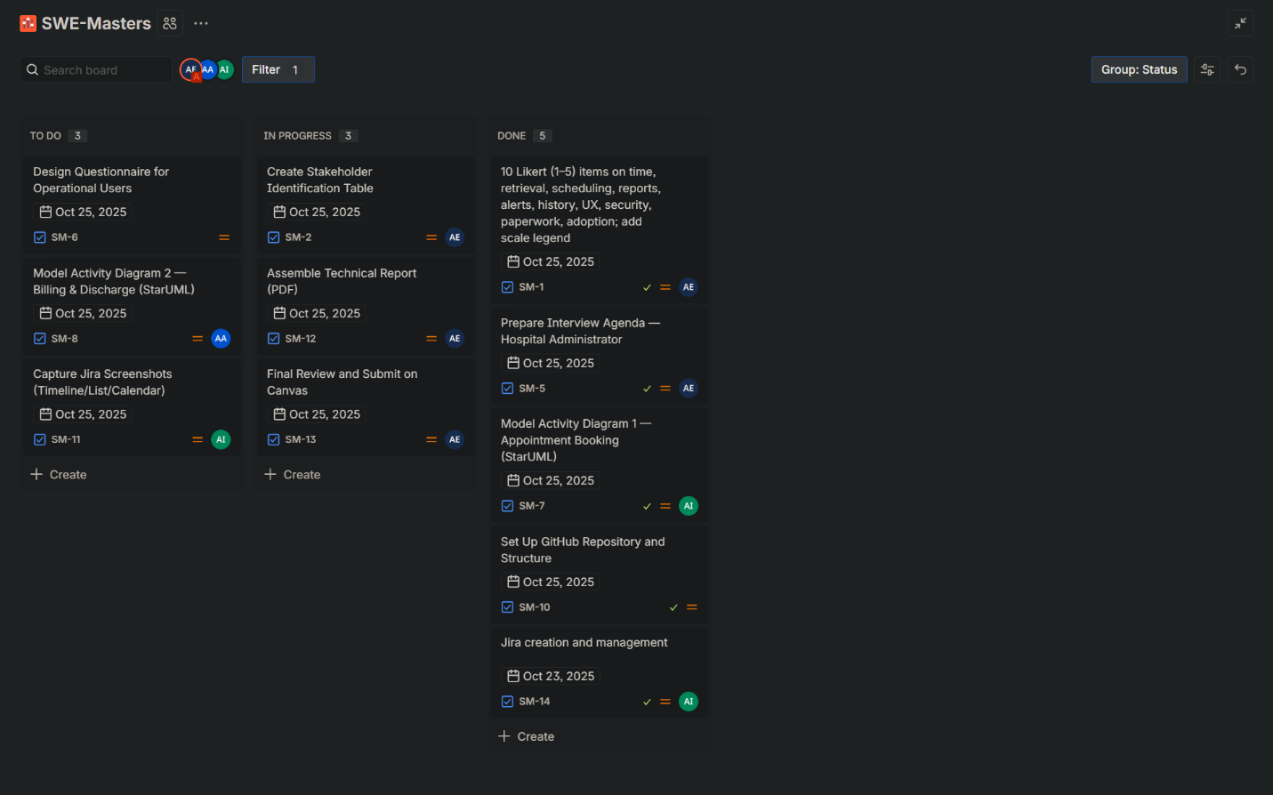
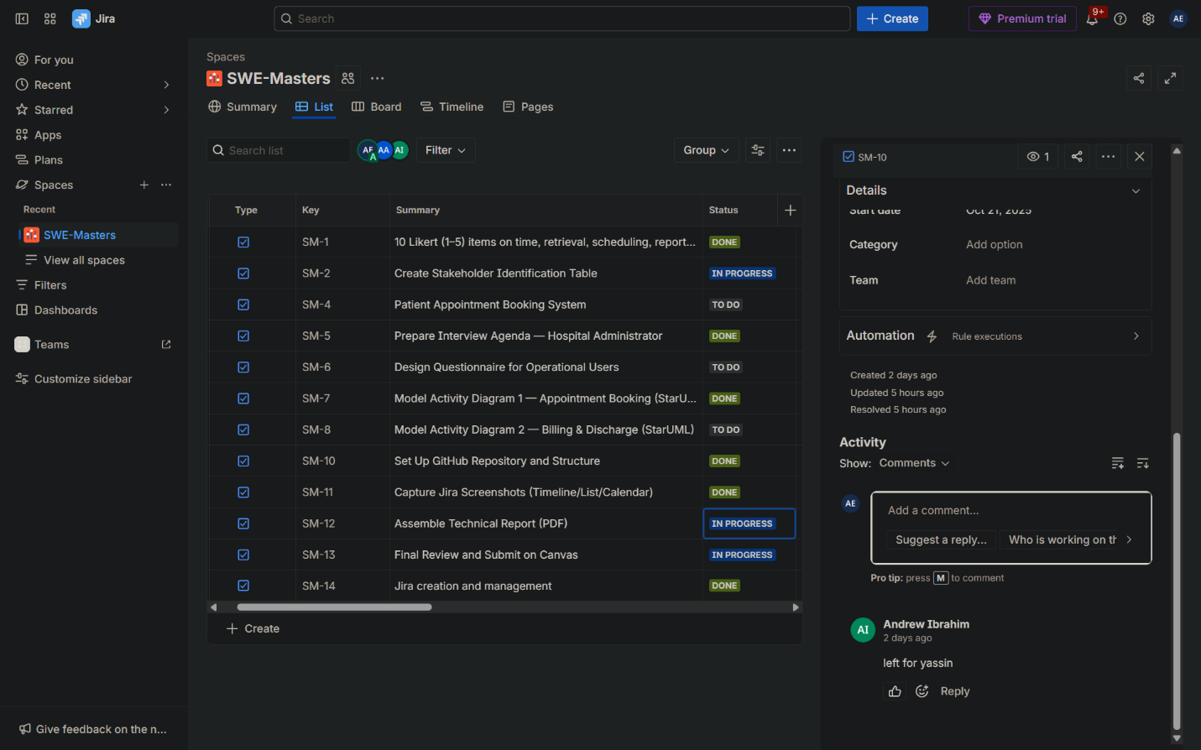

Our team used Jira's Project Management template to organize and track all deliverable tasks. We created 15 tasks covering report sections, StarUML diagrams, and tool setup, assigning each to specific team members with clear start and due dates aligned to the October 25 deadline. We monitored progress daily using the List and Timeline views, updating task statuses from To Do to In Progress and Done. The Timeline view helped us visualize dependencies and ensure timely completion, while the List view provided a quick status overview. This approach ensured accountability, transparency, and on-time delivery of all components.

Assumptions
The following assumptions were made during the development of the Hospital Management System (HMS) vision and requirements:
- Notifications:
The system sends appointment confirmations via SMS, Email, or the Patient Portal.
- Pharmacy Module:
Pharmacy management is optional and considered out of scope for Deliverable 1.
- Role-Based Access:
The system includes distinct access permissions for the following roles: Admin, Doctor, Receptionist, Nurse, Billing Staff, and Pharmacist.
- Data Backup:
Automated daily backups are assumed to be configured and maintained by system administrators.
- Payment Methods:
The system supports cash, card, and online payment processing.
- Compliance:
The system must comply with applicable healthcare data protection regulations (e.g., HIPAA or local equivalents).

